**1.INTRODUCTION**

*1.1 Overview*

WebThe chapter proposes to outline best practices in the use of a set of mini-robots (i.e., smart gadgets) to promote active and meaningful learning in the Social Sciences. Key K-12 social science skills supported by their use include coding, sequencing, including time lining.

A smart device is an electronic device, generally connected to other devices or networks via different wireless protocols (such as Bluetooth, Zigbee, near-field communication, Wi-Fi, LiFi, or 5G) that can operate to some extent interactively and autonomously

*1.2 purpose*

Smart gadgets have become an integral part of our daily lives, and they have several uses12. Here are some examples of how smart gadgets are used in our daily lives:

Communications: Smartphones are excellent at keeping us connected1.

Internet Access & Web Browsing: Smartphones have built-in Wi-Fi or cellular data connections, which grant us instant access to the internet1.

Productivity and Organization: Smart gadgets can help us stay organized and productive12.

Entertainment: Smart gadgets can be used for entertainment purposes, such as watching videos or playing games1.

Photography & Videography: Smart gadgets can be used to take photos and videos1.

**2.LITERATURE SURVEY**

*2.1 Exiting Problem*

Smart home devices, like Amazon's Alexa and Google's Nest, as well as 5G wireless networks, are transforming homes. They're no longer static shelters, but rather, personal spaces for hyper-connected living.

According to McKinsey's "The Connected Home Market" report, consumers are most motivated by utility management, as well as security and safety when buying connected home technologies. For example, the most common purchases are smoke detectors, remote video, smart thermostats and connected locks.

Wireless tech is becoming a permanent home companion. However, these systems bring a few challenges and risks that we explore below.

*2.2 Proposed Solution*

Lately, more and more technologically advanced innovations are taking shape in handheld or mobile gadgets. Smartphones aren’t the only smart gadgets we use these days. We have the smartwatch, smart TV, smart cars, and more. But not all gadgets that carry the label “smart”, are actually smart, it just means that it is connected to the smartphone via an app or via Bluetooth.

Keeping that at the back of our heads, we dug around for gadgets with above-average smarts, the kind that helps make our life easier. We found a few items that can help you keep track of your things, a very smart lock that can also help save your life as well as a pen that will change the way you work online. Let’s take a look.

**3.THEORITICAL ANALYSIS**

*3.1 Block Diagram*

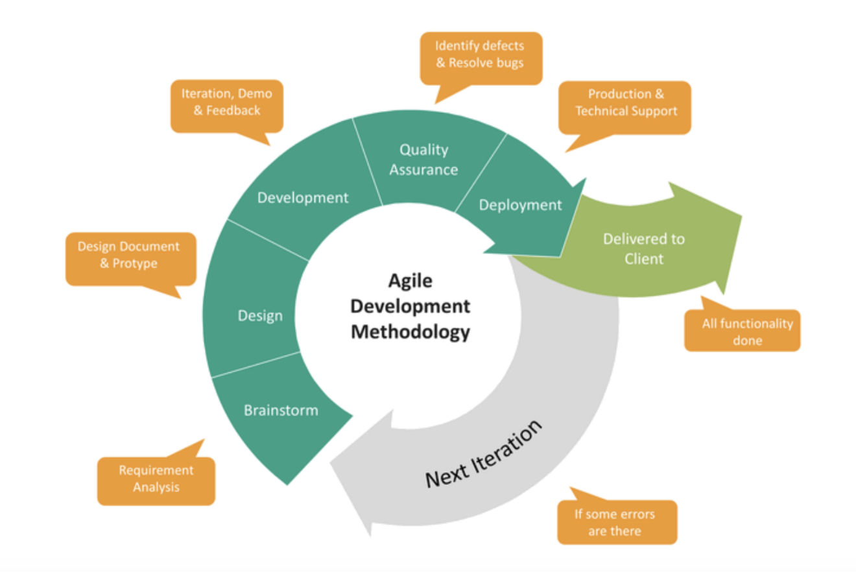*3.2 Hardware/Software Designing*

Hardware:

We have used Laptop,Keyboard,Mouse etc. like other acquipments in our project.

Software:

We have learned HTML,CSS,JAVASCRIPT coding in our project.

**RESULT**

A smart gadget is known to be an electronic device which is interlinked with other networks or devices by making use of different wireless protocols such as Wi-Fi, Bluetooth, NFC, 3G, etc. They have the capability to work autonomously and interactively. Modern technology has revolutionized the old technology and has made a huge impact in everyone’s life. We make use of smart gadgets in daily lives in different ways. Some of the common examples of smart gadgets are smart key chains, smart bands, smartwatches, smartphones, tablets and phablets. It can also be known to have artificial intelligence.

Smart gadgets are known to work in different ways in an environment. They possess different properties and are adaptable to computing environment, human environment as well as to the physical world. In today’s world one of the recommended gadget which everyone must have is a smartphone. The technology of smartphone has tremendously changed all over the world. Many societies have been beneficial from them. Smartphones which are available in the market possess properties and characteristics which make them unique, outstanding and attractive. This has become a necessity since the outdated black and white phones are no more of use. Some of the major properties which attract a person is because of their ease of software, High Resolution camera, expandable memory, videos and games.

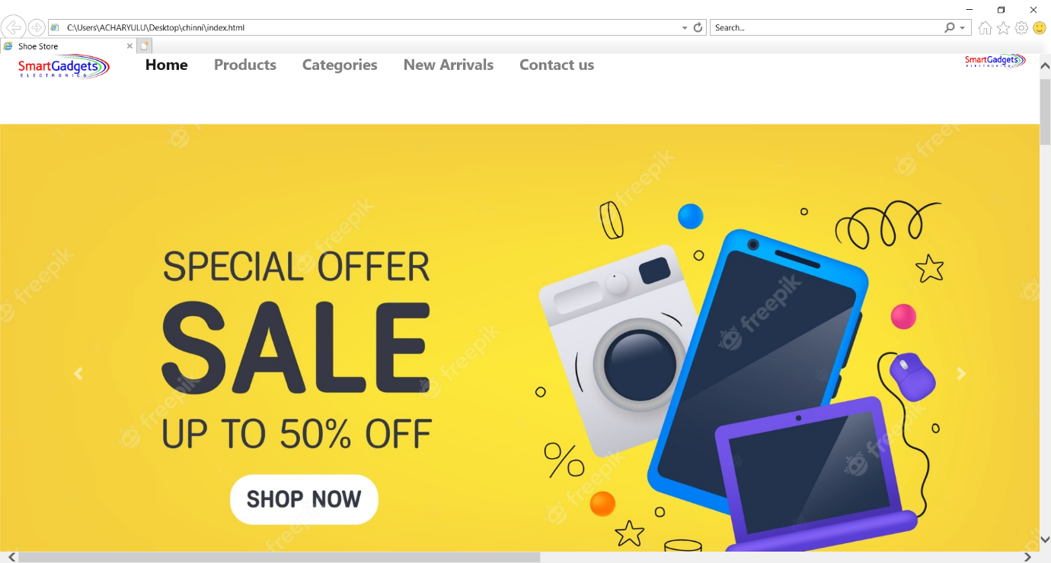

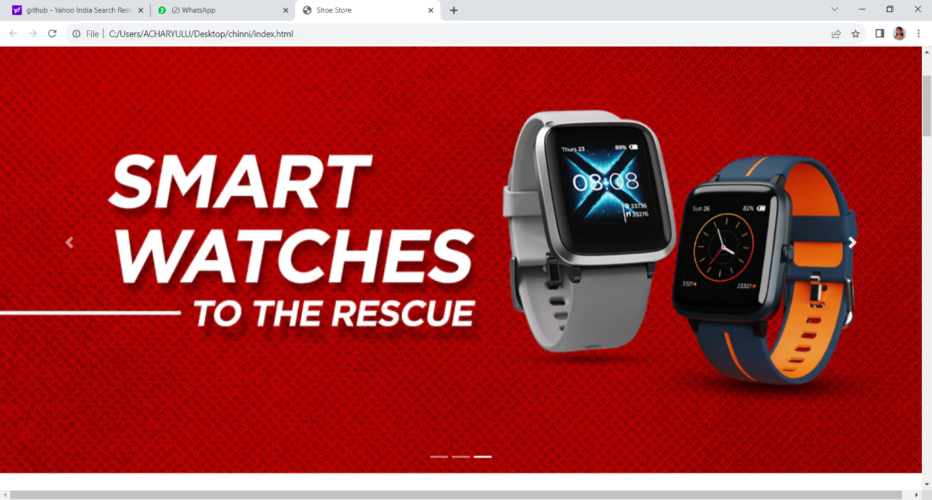

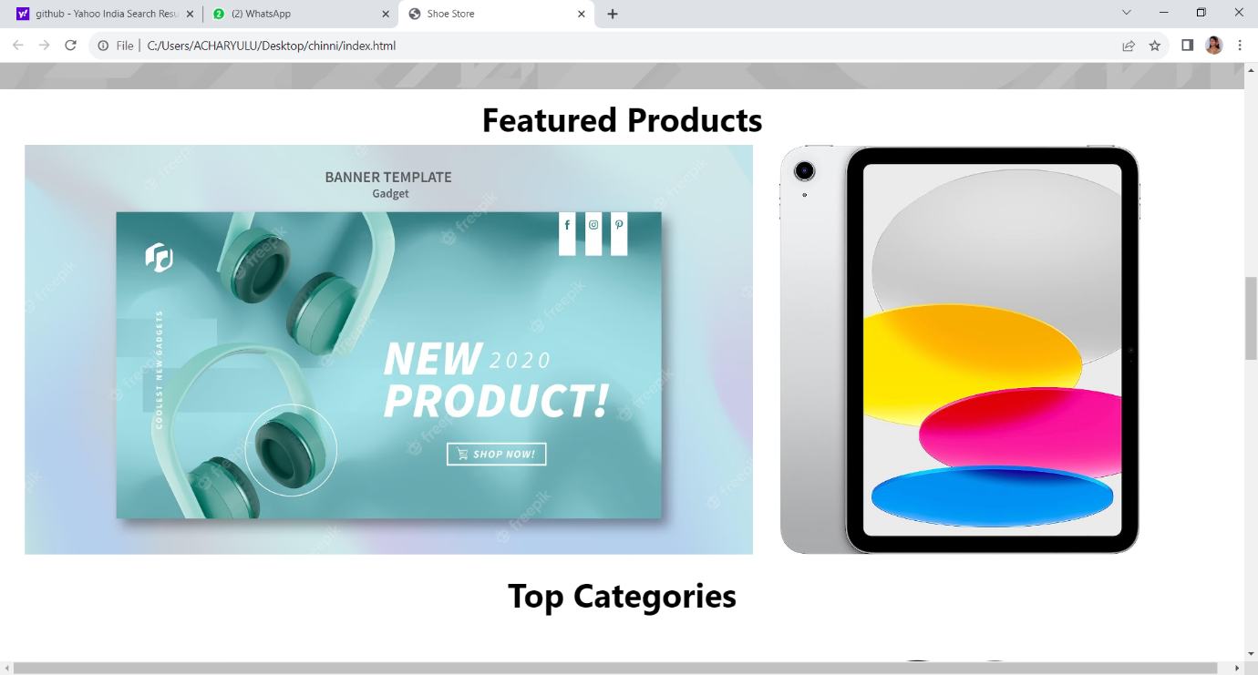

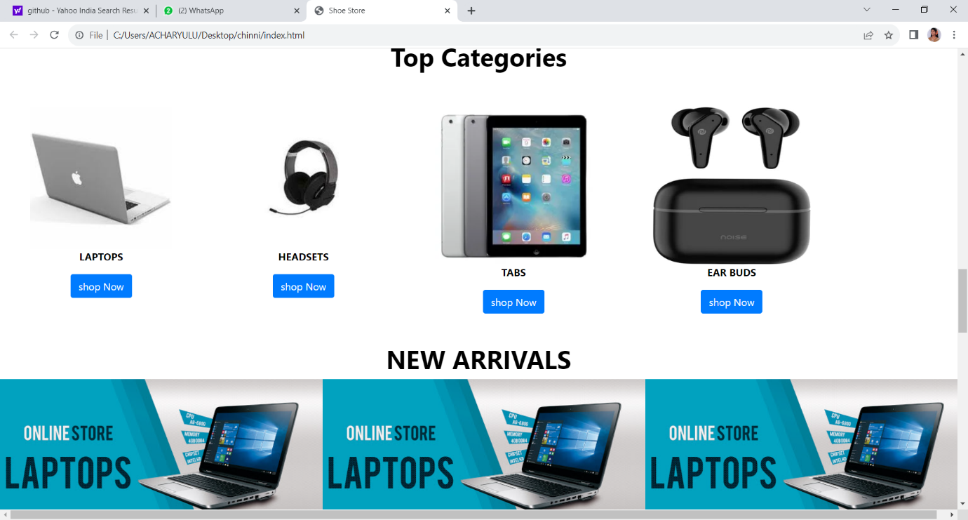

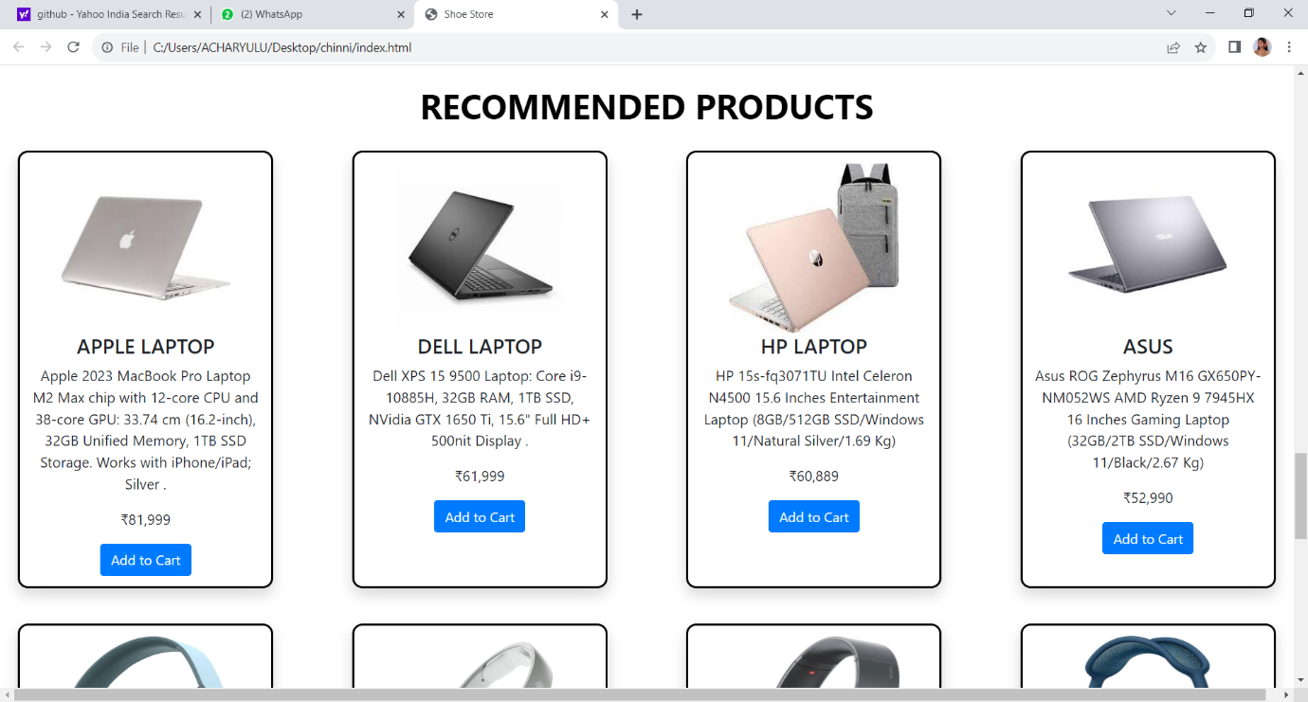

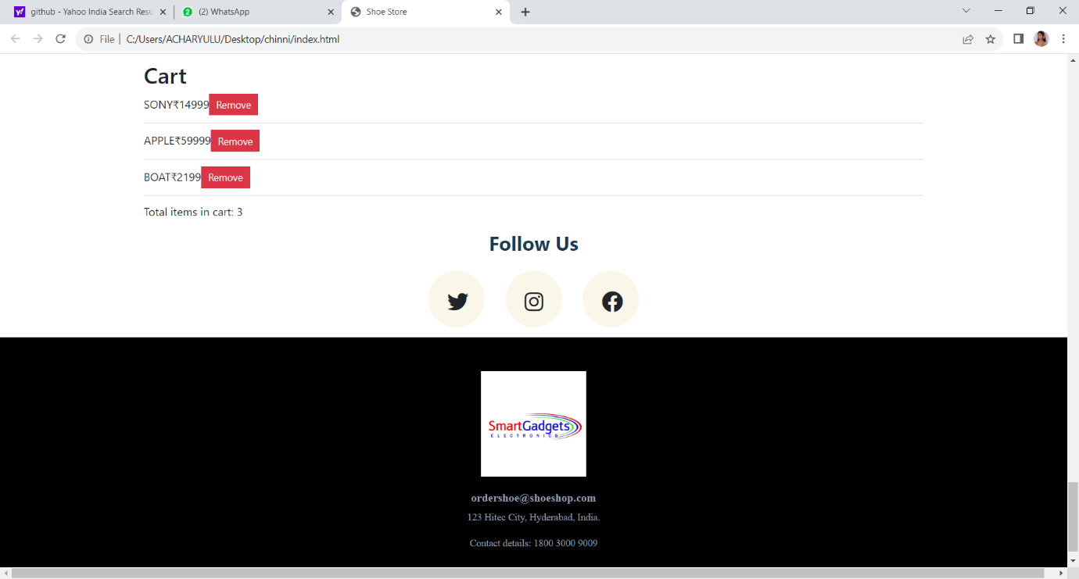

**ADVANTAGES & DISADVANTAGES**

E-commerce, commonly referred to as electronic commerce or internet commerce, is the term used to describe the exchange of money and data to transact business through the internet. E-commerce, which can apply to any form of economic transaction made possible by the internet, is frequently used to refer to the online selling of tangible goods.

*Advantages of E-Commerce*

We now understand the benefits of e-commerce. Whether a person is a client or a businessperson, everyone wins from this.

1. Selling Internationally

It is a platform where any trader or business may advertise their goods as much as possible around the globe. Additionally, anybody can purchase the item for themselves from any location.

In this, communication between the client and the merchant is simple. E-commerce functions as a worldwide business model as a result. The businessman may boost the worth of his product brand by doing this.

2. Accessibility

Anything may now be purchased quite easily. On the e-commerce platform, products are accessible around the clock. Compared to offline markets, it is considerably better.

3. Cheap

The client and the firm are linked directly through this business strategy. Because of this, any business or group may offer their goods directly to consumers. The business could increase its margin in this. The same client can purchase the good or service for less money online than in a physical store.

4. Domestic Delivery

A customer's requested item is quickly delivered to his home via an e-commerce company. Additionally, client complaints are addressed along with this. People prefer to purchase goods online because of this.

*Disadvantages of E-Commerce*

If you believe that using E-Commerce or conducting your buying online is safe. Therefore, your reasoning is wholly incorrect. Because it has benefits, there are some drawbacks as well, which are listed below.

1. Safety

E-Commerce has a significant issue from online fraud. Hackers steal personal information, financial information, and other data from websites. The issue of hacking persists because of any negligence.

No website makes any assurances that your personal information won't be compromised, and hacking has always been seen as a drawback of e-commerce. Therefore, create a secure password for your online store.

2. Fear

When purchasing online, most of the shops lack a physical presence, and before completing online payment, customers have reservations about this. People worry that they will lose their money if the wrong goods are delivered and that it would be challenging to obtain their money back if the website is unreliable.

3. Some things are difficult to purchase online

if you believe that you can buy everything and everything online. You are, therefore, completely mistaken in your thinking. Some necessary items and valuables are challenging to purchase online. People believe it is more appropriate to purchase items like jewelry from brick-and-mortar stores rather than online.

4. Delivery Is Late

You are granted a specific amount of time while buying on an e-commerce website, after which you will get your purchase. However, this seldom occurs, and for some reason, the merchandise usually arrives to you sooner than promised.

**APPLICATIONS**

E-commerce applications is a somewhat confusing terminology since it may lead to two different interpretations: one that refers to the use of e-commerce as a marketing medium; retail and wholesale; auctioning; e-banking; booking, and so on.

E-commerce applications is a slightly confusing phrase since it leads to two different perceptions: one where it refers to the use of e-commerce as a medium of marketing; retail and wholesale; auctioning; e-banking; booking, and so on.

The second concept that comes to mind is a software program like Amazon, eBay, Groupon, etc. It might be a web application or applications of e-commerce (now popularly known as m-commerce applications). Mobile e-commerce applications are just an extension of e-commerce. Mobile app concepts are the driving force behind any successful business app, whether a cab booking app or a food delivery app.

**CONCLUTION**

E-commerce still represents one of the business methods that take advantage if done the right way, even if the stock market and commodities fell, but E-Commerce still able to survive and receive high transaction. E-commerce has a tremendous opportunity in the course of or business in Malaysia. In addition, it is also to introducing new techniques and styles in a transaction. Use the extensive E-Commerce in the Internet world is actually much better to bring the goodness of the individual or the state.

E-Commerce has undeniably become an important part of our society. The successful companies of the future will be those that take E-Commerce seriously, dedicating sufficient resources to its development. E-Commerce is not an IT issue but a whole business undertaking. Companies that use it as a reason for completely re-designing their business processes are likely to reap the greatest benefits. Moreover, E-Commerce is a helpful technology that gives the consumer access to business and companies all over the world.

**FUTURE SCOPE**

It is really good now and in the future, thanks in part to the increase in the number of online users on the Internet audience.

Future Scope of ecommerce

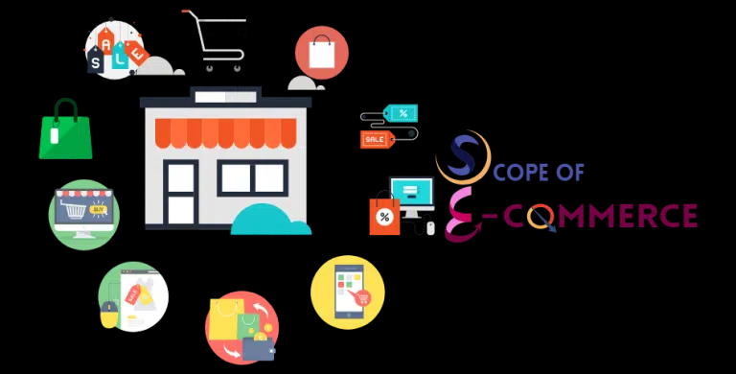

Before diving into the future and future scope of eCommerce in India, let’s first understand,

what e-commerce is. In simple terms, the scope of eCommerce refers to the buying and selling of goods online or over the Internet users.

their products with prices and descriptions. Shoppers who buy products have multiple payment options such as cash on delivery, e-wallets, online banking, credit cards, and more. Online sellers are responsible for delivering goods to customers and ensuring safe and timely delivery.

Future Scope of ecommerce and Future of Online Shopping.